**OUTPUT SCREENSHOTS:**

A dropdown menu from which users can select the city:

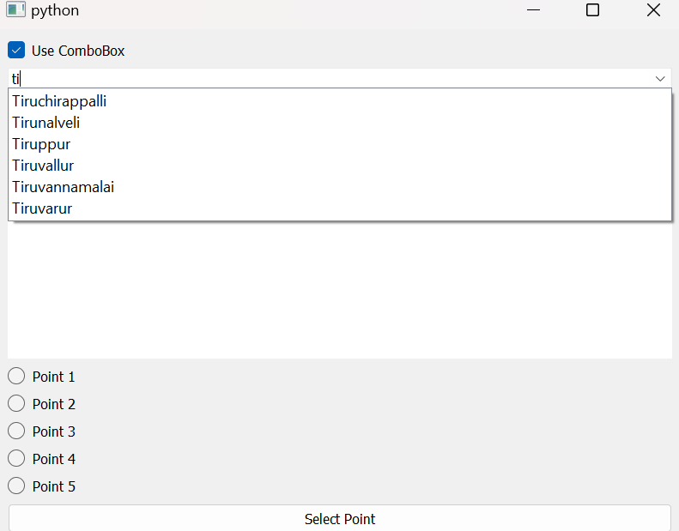

Sample1:

City – Coimbatore

Location – Amrita Vishwa Vidyapeetham

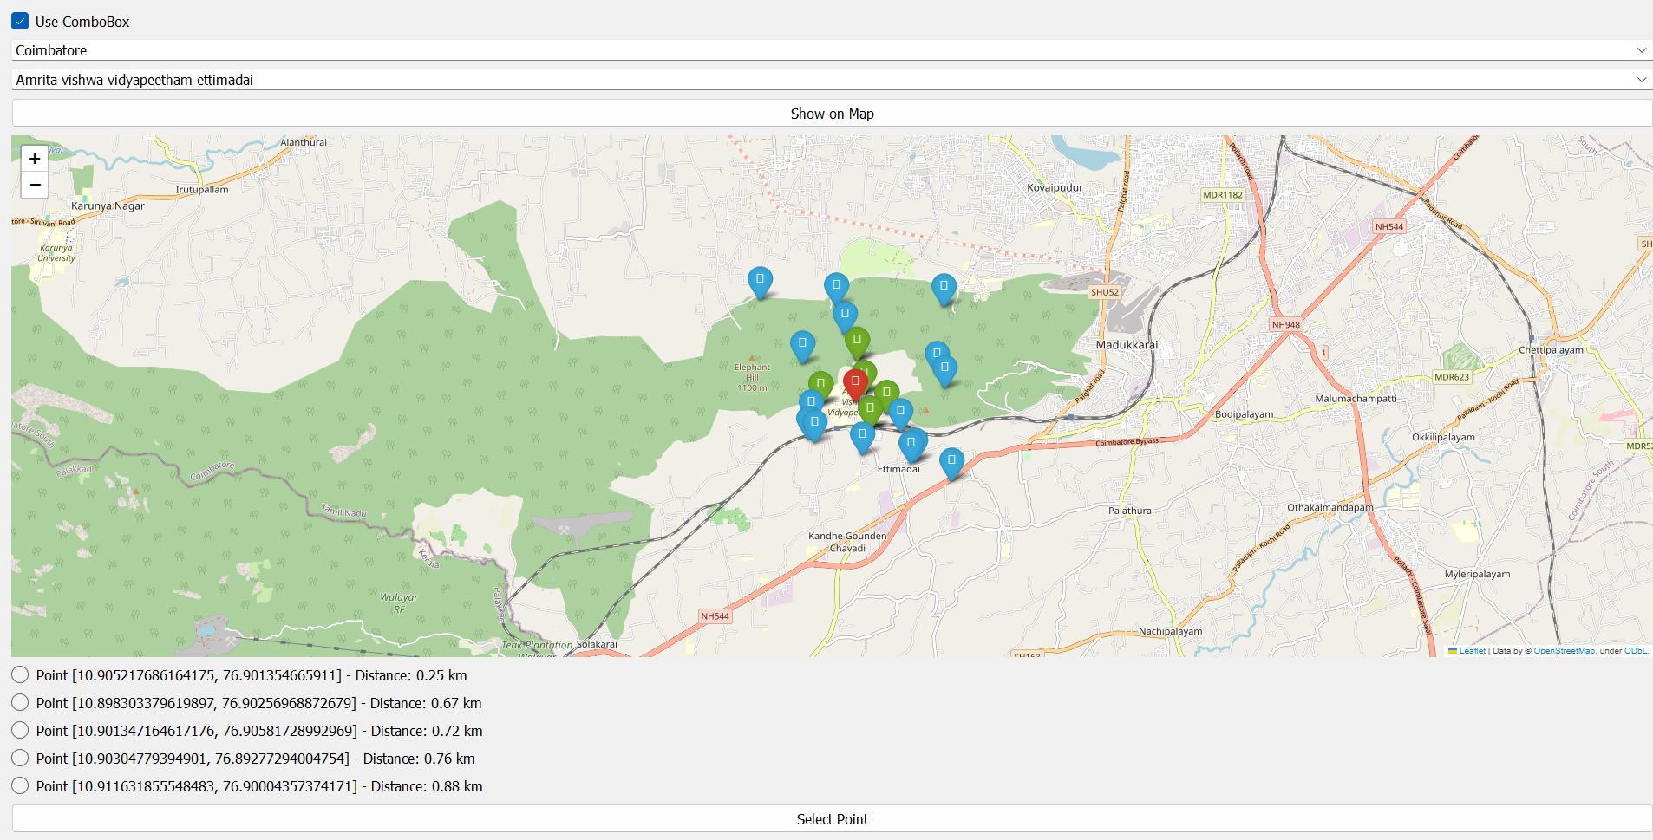

Sample 2:

City – Coimbatore

Location – Coimbatore Airport

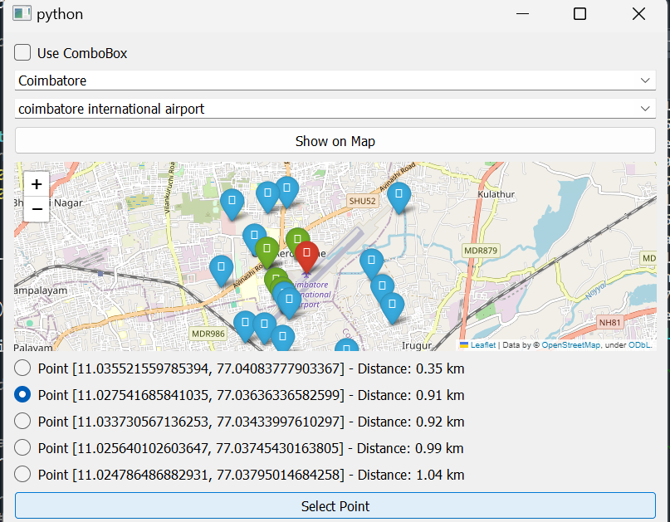



**Note:**

Red marker – Selected city

Blue points - random neighbours near the selected city

Green markers – top 5 nearest neighbours.

Sample 3:

City – Chennai

Location – Marina Beach

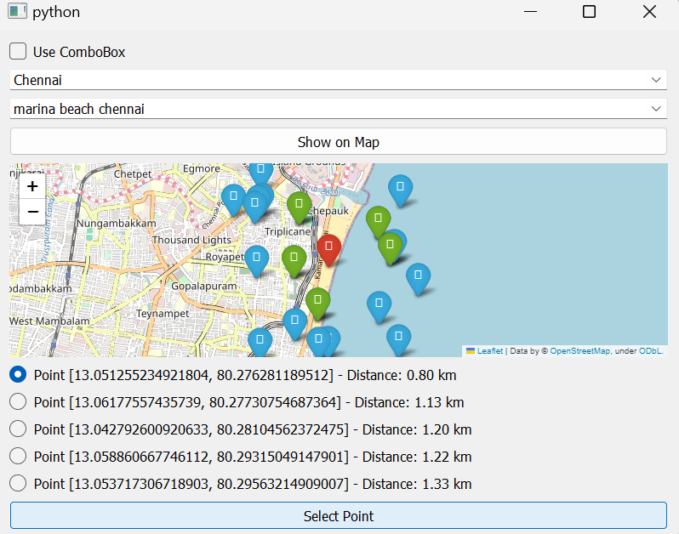

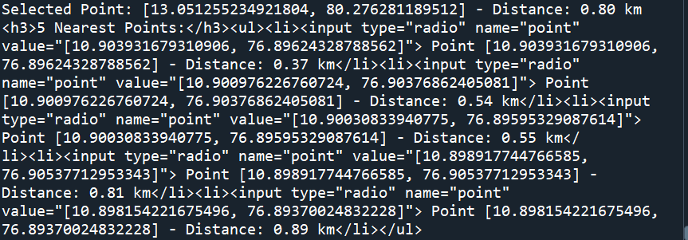

Sample 4:

City – Chennai

Location – Anna Nagar

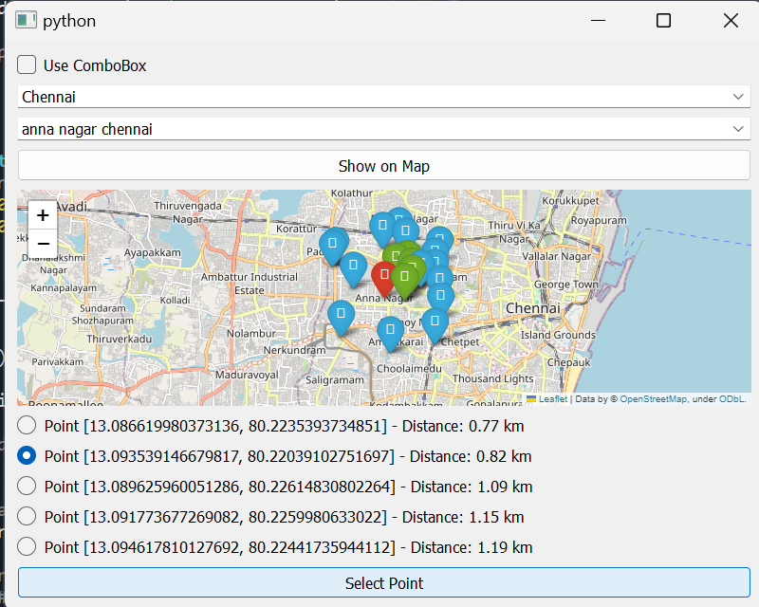

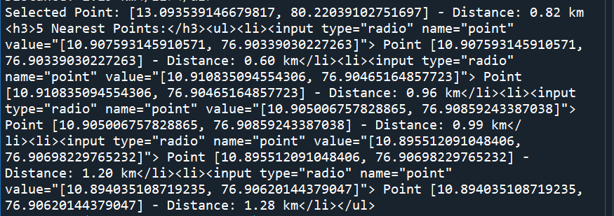

Sample 5:

City – Coimbatore

Location – Le Meridien

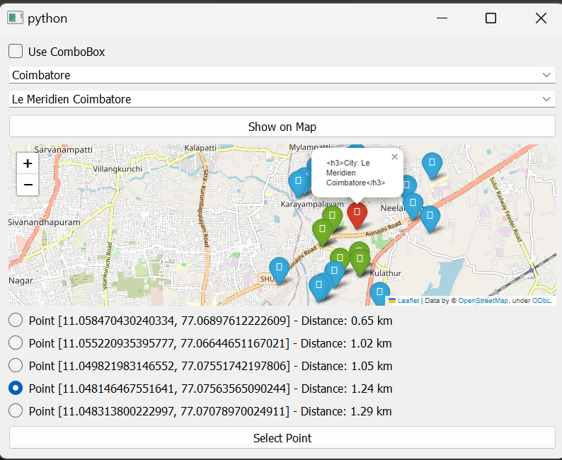

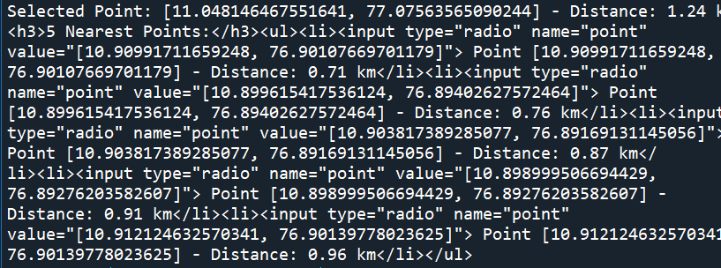

After selecting 5 places, it throws a discount.  
[Indicating that users has availed services for 5 times]

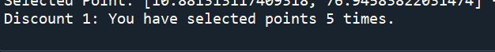

Console output:  
[Refreshed points will be displayed every 5 seconds, as in real time, neighbours like cars will be in motion]

